<<COURT_NAME>>

|  |  |
| --- | --- |
| <<PROVIDER_SUITNAME>>,  a/a/o <<INJUREDPARTY_NAME>>    Plaintiff,  vs.  <<INSURANCECOMPANY_SUITNAME>>  Defendant. | Case No. <<INDEXORAAA_NUMBER> |

__________________________________________/

**CIVIL COVERSHEET**

**I. CASE STYLE:** See Above.

**II. AMOUNT OF CLAIM:** $<<BALANCE_AMOUNT>>

**III. TYPE OF CASE:** Circuit Civil; Other; Insurance Claims

**IV. REMEDIES SOUGHT:** Monetary

**V. CAUSE(S) OF ACTION:** (1) Breach of Contract

**VI. CLASS ACTION?** No.

**VII. RELATED CASES?** None.

**VIII. JURY TRIAL?** Yes.

I CERTIFY that the information I have provided in this cover sheet is accurate to the best of my knowledge and belief, and that I have read and will comply with the requirements of Florida Rule of Judicial Administration 2.425.

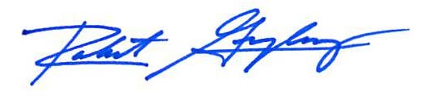

Robert F. Gonzalez, Esq.

Fla. Bar No. 68865

Date: February 18, 2022